Q WRITE QUERY TO CREATE FOLLOWING TABLE STRUCTURE:
Employee(emp_id,
Name,department,salary,city)
- Insert minimum 10 records
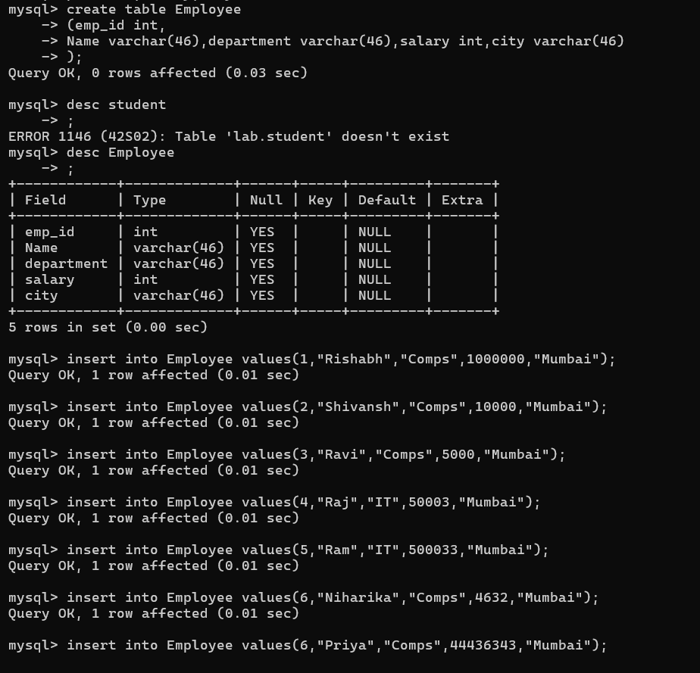
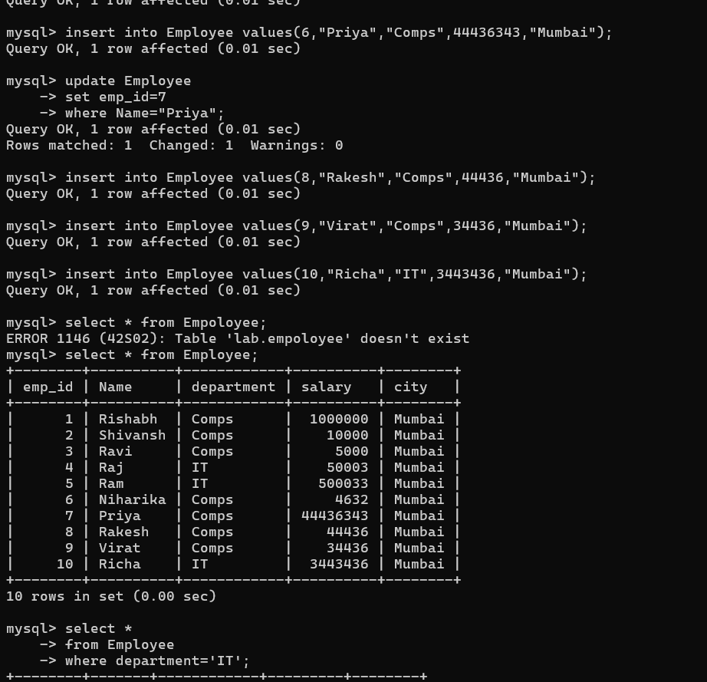

- Insert minimum 10 records
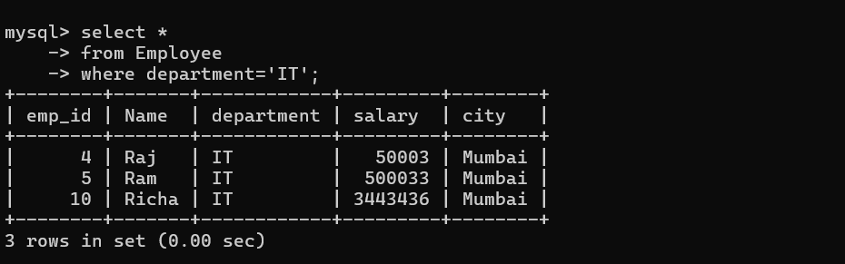
- c) Display employees whose salary is greater than 30000
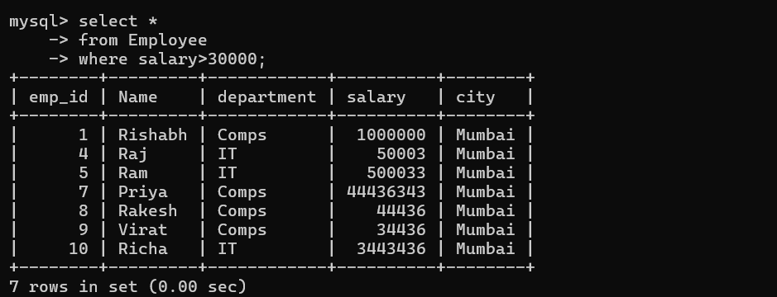
- d) Update salary of Ravi by 5000
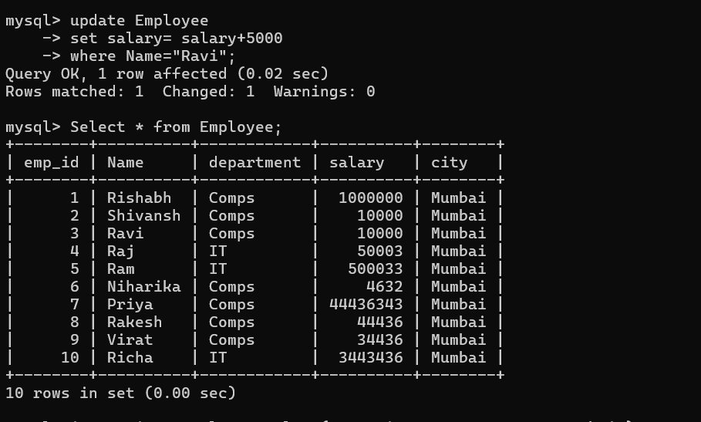
- e) Change city of Amity to Mumbai
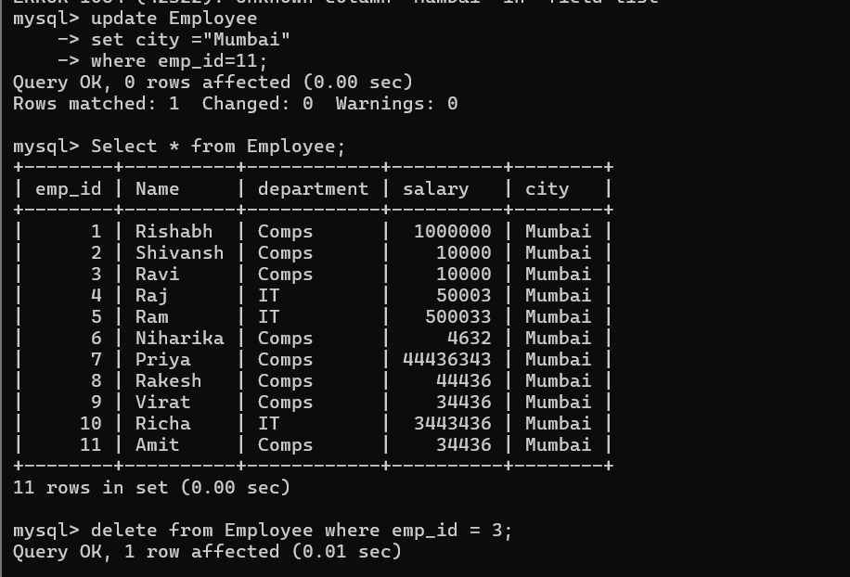
- f) Delete employee whose empid is 3

